Save the Habitat.
Save The Hunt.
Illinois NWTF State Chapter
Strategic Plan

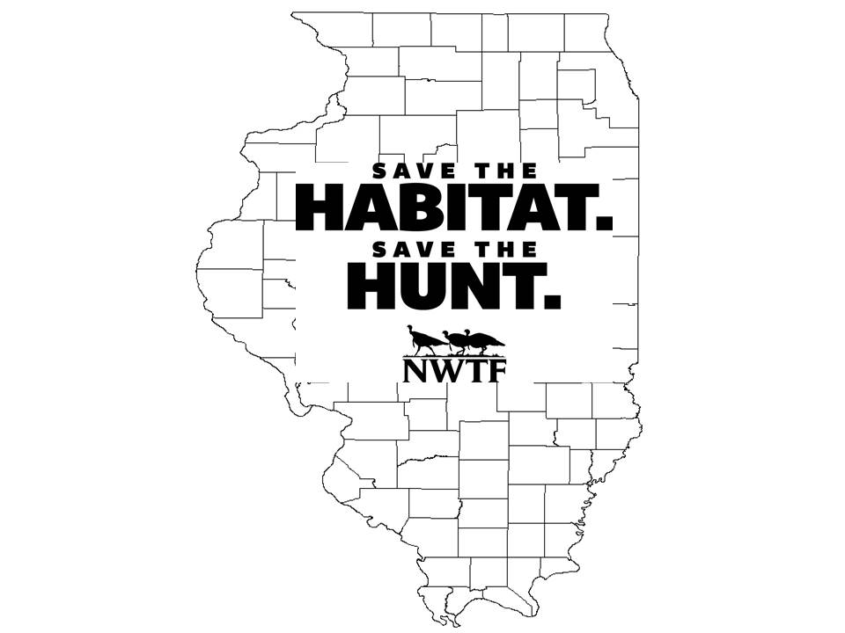
Table of Contents

Diagram of Strategic Plan 3

Habitat Enhancement Objectives and Strategies 4
Objectives 4
Strategies 4&5

Access Enhancement Objectives and Strategies 5
Objectives 5
Strategies 5

Hunt Enhancement Objectives and Strategies 5
Objectives 5
Strategies 6

Figure 1. Map of Illinois NWTF Focal Landscapes 7

Values: The IL-NWTF values ethical hunting, opening access to hunting, and educating others about hunting

Vision: More turkeys, More places to hunt, Preserving the hunt
Mission: The NWTF is dedicated to the conservation of the Wild Turkey and the Preservation of our hunting heritage.
National Goals: 4 Million Acres; 1.5 Million New Hunters; 500,000 Access Acres

Strategic Access Issues for the Future
Only 3% of Illinois is publically accessible. Therefore, additional public access areas are needed as we grow our hunter numbers.
Strategic Hunt Issues for the Future
We need more hunting heritage events and need to transform existing ones to create hunters of all ages, not just introduce youth to shooting

Strategic Habitat Conservation Issues for the Future
Forest Quality – Oak age class, composition shift, invasive species, savanna, glade restoration
Forest Quantity – With much of the state in crop and exotic cool season forage pastures, restoring forested land, where feasible, will be important

Create 27,700 New Hunters
- Expand Mentored Hunting
- Support Hunter Safety Training

175,000 Acres Conserved/Enhanced
- Seed Program – 400 acres /year
- Super Fund – 9,600 acres/year
- Equipment – 15,000 acres/year

Improve Public Access by 5,000 Acres
- Open closed lands – 200 acres/year
- IRAP – 3,000 acres

- Remove barriers to Firearms Safety
- Recruit hunter safety instructors to Committees
- Each Chapter host/sponsor a field day
- Coordinate with state agency and Hunter Education Program to link classes more seamlessly with mentored hunting opportunities
- Expand/Increase Mentored Hunts
- Youth, Family, WITO, etc.
- Expand/improve existing dove hunting program
- Cooperation with other NGO’s
- Work with NASP, 4H, IRAP marketing mentored hunts directly to kids
- Create a web-based clearing house linking new hunters with available mentors
- Create a Hunter Recruitment Retention Calendar for all seasons, hunts, clinics, safety clinics, shows
- Expand urban deer hunting opportunities
- Open existing lands to any levels of hunting
  - Conservancy lands - TNC
  - Public lands – Corp of Engineers, Parks , SNAs. Limited access for special hunts
  - Encourage/promote expansion of urban hunting opportunities for deer hunting
  - Project forester will continue to work with the IRAP program writing management plans that result in improved habitat and create public access to private lands.
- Increase Super Fund and secure 8:1 Match
- Seek Focal Landscape Grants
- Expand Seed Programs
  - Increase use of seed subsidy program.
  - Advertise Seed Program better
- Stewardship Contracting with Shawnee
- Expand regional forester delivery in Rivers of Trees and Driftless Area Focal Landscapes.
- Expand Southern Illinois Prescribed Fire Council impact in Shawnee Hills Focal Landscape.
- Improve partnerships with other NGO’s

Annual checkpoints for acreage goals and current match rate will occur at the June Board Meetings

Annual checkpoints for acreage goals and current match rate will occur at the June Board Meetings

Annual checkpoints for acreage goals and current match rate will occur at the June Board Meetings

Habitat Enhancement Objectives and Strategies
These overarching habitat enhancement objectives pertain to all of the Focal Landscapes identified for Illinois.

Objectives
- Conserve and/or enhance 175,000 Acres of habitat state-wide emphasizing strategically identified focal landscapes
  - Improve the quality of 45,000 acres of forest land throughout the Shawnee National Forest over the next ten years, or 500 acres annually in open woodland restoration projects and managing scattered openings of various sizes throughout the forest that will improve nesting and brood-rearing habitat for wild turkeys. Annually augment the burning program that will enable 4,000 additional acres to be burned.
  - Improve the quality of 18,000 acres of open woodland habitat in the Shawnee Hills focal landscape over the next ten years, or 1,000 acres annually for wild turkey nesting and brood-rearing habitat.
  - Restore 10,000 acres of open woodland habitat within the Rivers of Trees Focal Landscape over the next 10 years, or 1,000 acres annually through the efforts of our regional forester for wild turkey nesting and brood-rearing habitat.
  - Enhance 2,000 acres for brood-rearing habitat and fall and winter supplemental feeding areas for wild turkey through our Seed Subsidy Program.
  - Enhance 100
  - 100,000 acres with equipment that we assist in purchasing for use on public and private lands throughout the state.

Strategies
- Identify three habitat Focal Landscapes, including determination of the most pressing conservation issues in each focal landscape and potential improvement practices and partners, both traditional and non-traditional.
  - Driftless Area, Illinois River & Kaskaskia River (Rivers of Trees), and Shawnee Hills southern Illinois.
- Identify acreage goals for habitat enhancement objectives within each of the selected Focal Landscapes.
- Identify at least one Focal Area within each Focal Landscape for initial conservation delivery.
- Improve quality and quantity of brood-rearing and fall and winter feeding areas through the Seed Subsidy Program.
- Improve quality of forested acres within Focal Landscapes through expanded partnerships and implementation of the habitat improvement practices listed below:
  - Forest stand improvement practices including Timber Stand Improvement and treating invasive species.
  - Prescribed burning in woodlands and savannas.
- Increase funding support of conservation delivery in the state of Illinois.
  - Increase annual Super Fund balance by 50% and increase the match ratio.
  - Increase current project match from 5:1 to 8:1 on conservation projects. Emphasize the need for improved match with our state and federal partners
  - Work with NWTF staff in development and field operations to garner major gifts to enhance conservation delivery within each Focal Landscape.
  - Seek Focal Landscape-based grants to address known habitat deficiencies from Habitat Stamp Fund and others.
  - Seek granting sources to expand impact of regional foresters(s).
- Pursue Stewardship Agreements with Shawnee National Forest.

Access Enhancement Objectives and Strategies
Detailed below are the objectives pertaining to improving hunter access in the state of Illinois over the next ten years.

Objectives
- Improve Public Hunting Access to 10,000 Acres over the next ten years through partnerships opening currently closed public properties.

Strategies
Open existing lands to public hunting through negotiations.
  - Conservancy lands – TNC
  - Public Lands – parks, SNAs, Army Corps of Engineers
  - Look at expanding use of urban deer hunts.
  - Project forester will write management plans for IRAP properties that will result in public access to private land.

Hunter Recruitment Objectives and Strategies
Detailed below are the objectives pertaining to maintaining and increasing the number of licensed hunters in the state of Illinois over the next ten years.

Objectives
- Create 27,700 new licensed hunters by removing legislative barriers to hunting, expanding mentored hunting, and actively supporting hunter safety training in Illinois.

Strategies
- Remove legislative and regulatory barriers to hunting.
  - Ask for all-day turkey hunting during youth season.
  - Work towards all day hunting during regular season.
  - Ask that youth tag be valid until filled.
  - Ask that apprentice license be extended from 1 to 2 years.
  - Create an online Hunting Education Calendar that shows all seasons, clinics, events, shows, etc. for all partners
- Expand Mentored Hunting (5 new hunters through mentored hunts per chapter = 500)
  - Create women, adult and family-oriented mentored hunts
  - Cooperate with other organizations like Boy Scouts, Girl Scouts, Big Brother Big Sister, etc.
  - Work with NASP, 4H Shooting Sports, etc. to market mentored hunts to their participants.
  - Expand/improve existing dove hunting program and work to improve Learn to Hunt program run through Illinois Natural History Survey.
  - Help to promote IRAP program.
  - Work with state to create a web-based service linking new hunters with mentors.
- Support Firearms Safety Training
  - Identify how many of our members are already Hunter Safety Instructors.
  - Recruit additional Hunter Safety Instructors to committees, or encourage members to become instructors.
  - Increase existing number of members that are involved with the Hunter Safety courses but establish an initial goal of 2,270 (38% increase over existing 5 year average). The average class size is 44 (86x44x.60=2,270).
  - Each Chapter hold or sponsor a Hunter Safety Field Day. Consider holding them at mentored hunting properties.
  - Advertise Hunter Safety Classes and Field Days to members.
  - Work with state and HS Program to link timing of classes to mentored hunting opportunities.
- Work with the state to develop a shared New Hunter Coordinator position.

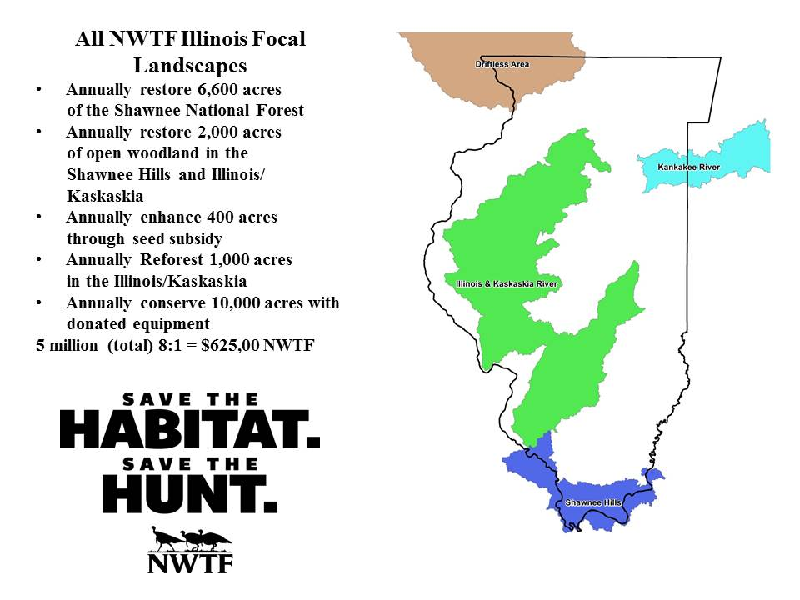

Figure 1. Map of Illinois NWTF Focal Landscapes

